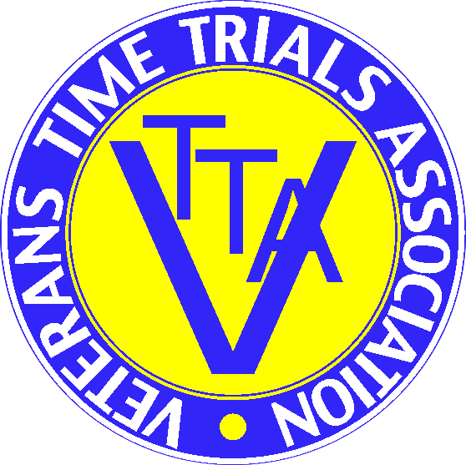 VTTA NORTH LANCS & LAKES OPEN 25
RESULT SHEET 14TH APRIL 2021
Promoted for and on behalf of Cycling Time Trials under their rules and regulations.
Event Sec. Richard Taylor, 23 Heywood Road, Castleton, Rochdale OL11 3AU 07533 679101
Timekeepers: Michael Addis and Richard Taylor
PRIZEWINNERS
FASTEST
Fastest | Sam Watson |  | Team Inspired |  | 51.27 | £40
2nd | Rhys Britton |  | Team Inspired |  | 51.46 | £25
3rd | Tony Cullen |  | Tricentral UK |  | 52.34 | £15
4th | Oscar Nilsson-Julien |  | Team Inspired |  | 52.38 | £10
Non VTTA vet | Tony Cullen |  | Tricentral UK |  | 52.34 | £20
Woman | Abi Smith |  | Team Breeze |  | 59.04 | £30
2nd woman | Debbie Moss |  | Team Merlin |  | 1.1.10 | £20
Espoir/Jun | Sam Watson |  | Team Inspired |  | 51.27 | £20
Best on Std | Debbie Moss |  | Team Merlin |  | +13.13 | £40
2nd | Dan Shackleton |  | ABC Centreville |  | +13.06 | £30
3rd | David Rundall |  | Chorley CC |  | 12.39 | £20
4th | Paul Fleming |  | Preston Whs |  | 10.57 | £15
Woman | Debbie Moss |  | Team Merlin |  | 13.13 | £30
2nd woman | Sue Cheetham |  | North Lancs RC |  | 7.06 | £20
Team of Three |  |  | Springfield Financial
 | Sean Owens |  |  |  | 9.07 | £10
 | Matt Stell |  |  |  | 8.16 | £10
 | Greg Plummer |  |  |  | 7.32 | £10
 |  |  |  |  | 24.55
There’s nothing more certain in life than death and taxes quoted Benjamin Franklin, he obviously never rode a 25 in Lancashire in April. The dreaded temporary lights appeared as if by magic on the eve of this much maligned event, where amendments to the course or distance of the event have become almost de riguer. This was the fourth consecutive year of some sort of interruption, but were we beaten? Perish the thought, with the spirit that made Lancashire what it is, the new course was made newer, and a 25 mile event was concocted to fulfil the afternoon’s activities. But none of this would have been possible without some serious assistance, especially from Val Leach who oversaw the signing on and off and number distribution. Mike Addis who stepped in at the last minute to perform as start timekeeper. Marshals on course were Bill Lloyd, Harry Haseley and Peter Haigh, with Jamie Carson and Jim Lawley having a trike riders love in whilst manning Miller Island. Recent new comer to the group John Ward helped me at the finish, whilst son Tom helped with the
signs. Many thanks to all. A big welcome to Richard Belk of the Kent Valley, who became our latest new member before the event.
Finally, a big congratulations to all the prizewinners in what has to be one of the fastest events ever run on our local roads. Alf Engers held Competition record when I first encountered time trialling in the mid-70s, 51.00 on a fast dual carriageway, so to witness a 19 year old rider, Sam Watson, come within 27 seconds of that landmark on a totally unremarkable twisting course is truly incredible. I’m sure we’ll hear plenty more about GB Academy rider Sam and his Team Inspired colleagues, Rhys Britton and Oscar Nilsson-Julien who incidentally bettered the 1969 team record, in the future, not to mention 19yo Abi Smith with a magnificent 59.04 and Patrick Casey whose speedy 56.12 was recorded at the tender age of 15.
Debbie Moss created history by being the first female to win the event on standard, beating all the men and women, well done!
Next event is the Clitheroe 25 on Wednesday 2nd June, followed by the Group 50 at Keswick on Sunday 4th July, entries to me. If you are over 40 and not a VTTA member, contact me about membership, £18 and good value!
Richard Taylor

